UNITED STATES

SECURITIES AND EXCHANGE COMMISSION

WASHINGTON, D.C. 20549

FORM 8-K

CURRENT REPORT

PURSUANT TO SECTION 13 OR 15(d) OF THE

SECURITIES EXCHANGE ACT OF 1934

Date of Report (Date of earliest event reported): July 28, 2020

G-III APPAREL GROUP, LTD.

(Exact Name of Registrant as Specified in Charter)

Delaware

(State or Other Jurisdiction

of Incorporation)

0-18183

(Commission File Number)

41-1590959

(IRS Employer

Identification No.)

512 Seventh Avenue New York, New York (Address of Principal Executive Offices)

10018

(Zip Code)

(212) 403-0500

(Registrant’s telephone number, including area code)

Not Applicable

(Former name or former address, if changed since last report)

Check the appropriate box below if the Form 8-K filing is intended to simultaneously satisfy the filing obligation of the registrant under any of the following provisions:

- Written communications pursuant to Rule 425 under the Securities Act (17 CFR 230.425)

- Soliciting material pursuant to Rule 14a-12 under the Exchange Act (17 CFR 240.14a-12)

- Pre-commencement communications pursuant to Rule 14d-2(b) under the Exchange Act (17 CFR 240.14d-2(b))

- Pre-commencement communications pursuant to Rule 13e-4(c) under the Exchange Act (17 CFR 240.13e-4(c))

Securities registered pursuant to Section 12(b) of the Act:

Title of each class | Trading Symbol(s) | Name of each exchange on which registered
Common Stock, $0.01 par value per share | GIII | The Nasdaq Stock Market

Indicate by check mark whether the registrant is an emerging growth company as defined in Rule 405 of the Securities Act of 1933 (§230.405 of this chapter) or Rule 12b-2 of the Securities Exchange Act of 1934 (§240.12b-2 of this

chapter). Emerging growth company ☐

If an emerging growth company, indicate by check mark if the registrant has elected not to use the extended transition period for complying with any new or revised financial accounting standards provided pursuant to Section 13(a) of the Exchange Act. ☐

Item 7.01. Regulation FD Disclosure.

G-III Apparel Group, Ltd. (the “Company”) announced the commencement of a private offering (the “Offering”) of $350 million aggregate principal amount of senior secured notes due 2025 (the “Notes”). Substantially concurrently with completion of the Offering, the Company expects to enter into the Second Amended and Restated Credit Agreement (the “Amended ABL Credit Agreement”), which the Company expects will be a five-year senior secured credit facility providing for borrowings in the aggregate principal amount of up to $650 million. The Amended ABL Credit Agreement will among other things, (i) extend the maturity date, subject to a springing maturity date if, subject to certain conditions, certain material indebtedness is not refinanced or repaid prior to the date that is 91 days prior to the date of any relevant payment thereunder and (ii) increase the interest rate margins and unused commitment fees thereunder.

Pursuant to Regulation FD, in connection with the Offering, the Company is furnishing as part of this Current Report on Form 8-K: (1) the section captioned “Summary—Summary Historical Financial and Other Data” of a preliminary offering memorandum, dated July 28, 2020, as Exhibit 99.1 and (2) an investor presentation, dated July 2020, as Exhibit 99.2. The information provided under this Item 7.01, including the exhibits attached hereto, is being furnished and shall not be deemed “filed” for purposes of Section 18 of the Securities Exchange Act of 1934, as amended (the “Exchange Act”), or otherwise subject to the liabilities of such section.

The information provided under this Item 7.01, including the exhibits, shall not be incorporated by reference into any filing under the Securities Act of 1933, as amended, or the Exchange Act, except as shall be expressly set forth by specific reference in any such filing. This Current Report on Form 8-K shall not be deemed an admission as to the materiality of any information in this Current Report on Form 8-K that is required to be disclosed solely by Regulation FD.

Item 8.01. Other Events.

On July 28, 2020, the Company announced that it commenced the Offering. The Company intends to use the net proceeds from the Offering to repay its term loan facility, to pay related fees and expenses and for general corporate purposes. A copy of the press release making this announcement is attached hereto as Exhibit 99.3 to this Current Report on Form 8-K and is incorporated herein by reference.

The information in this Current Report on Form 8-K is neither an offer to sell nor a solicitation of an offer to buy any securities.

Cautionary Language Concerning Forward-Looking Statements

Various statements contained in this Current Report (including the exhibits attached hereto) constitute “forward-looking statements” within the meaning of the Private Securities Litigation Reform Act of 1995. Forward-looking statements are based on current expectations and are indicated by words or phrases such as “anticipate,” “estimate,” “expect,” “will,” “project,” “we believe,” “is or remains optimistic,” “currently envisions,” “forecasts,” “plans,” “goal” and similar words or phrases and involve known and unknown risks, uncertainties and other factors that may cause actual results, performance or achievements to be materially different from the future results, performance or achievements expressed in or implied by such forward-looking statements. Forward-looking statements also include representations of our expectations or beliefs concerning future events that involve risks and uncertainties, including, but not limited to, the following:

- the outbreak of COVID-19 and its numerous adverse effects, including the closing of stores and shopping malls, the reduction of consumer purchases of the types of products we sell, the impact on our supply chain, restrictions on travel and group gatherings and the general material adverse effect on the economy in the U.S. and around the world, all of which negatively impact our business, sales and results of operations;

- our dependence on licensed products;

- our dependence on the strategies and reputation of our licensors;

- costs and uncertainties with respect to expansion of our product offerings;

- the performance of our products at retail and customer acceptance of new products;

- retail customer concentration;

- risks of doing business abroad;

- risks related to the recent adoption of a national security law in Hong Kong;

- price, availability and quality of materials used in our products;

- the need to protect our trademarks and other intellectual property;

- risks relating to our retail operations segment;

- our ability to achieve operating enhancements and cost reductions from the restructuring of our retail operations, as well as the impact on our business and financial statements resulting from any related costs and charges which may be dilutive to our earnings;

- the impact on our business and financial statements related to the early closure of stores or the termination of long-term leases;
- dependence on existing management;

- our ability to make strategic acquisitions and possible disruptions from acquisitions;

- need for additional financing;

- seasonal nature of our business;

- our reliance on foreign manufacturers;

- the need to successfully upgrade, maintain and secure our information systems;

- increased exposure to consumer privacy, cybersecurity and fraud concerns, including as a result of the remote working environment;
- the impact of the current economic and credit environment on us, our customers, suppliers and vendors;

- the effects of competition in the markets in which we operate, including from e-commerce retailers;

- the redefinition of the retail store landscape in light of widespread retail store closings, the bankruptcy of a number of prominent retailers and the impact of online apparel purchases and innovations by e-commerce retailers;

- consolidation of our retail customers;

- the impact on our business of the imposition of tariffs by the United States government and the escalation of trade tensions between countries;
- additional legislation and/or regulation in the United States or around the world;

- our ability to import products in a timely and cost effective manner;

- our ability to continue to maintain our reputation;

- the effect of regulations applicable to us as a U.S. public company; and

- the other risk factors described in detail in our Annual Report on Form 10-K for the fiscal year ended January 31, 2020, filed with the U.S. Securities Exchange Commission (the “SEC”) on March 30, 2020, and in our Quarterly Report on Form 10-Q for the fiscal quarter ended April 30, 2020, filed with the SEC on June 9, 2020, and in any subsequent filings with the SEC.

Although we believe that these forward-looking statements are based upon reasonable assumptions, these assumptions are based largely on our expectations and judgments and are subject to a number of risks and uncertainties, many of which are unforeseeable and beyond our control. Accordingly, we cannot give any assurance that our expectations will in fact occur and caution that actual results may differ materially from those in the forward-looking statements. Given these uncertainties, prospective investors are cautioned not to place undue reliance on these forward-looking statements. A detailed discussion of significant risk factors that have the potential to cause our actual results to differ materially from our expectations is described under the heading “Risk Factors” in our filings with the SEC. We undertake no obligation to publicly update or revise any forward-looking statements, whether as a result of new information, future events or otherwise, except as required by law.

Item 9.01. Financial Statements and Exhibits.

(d) Exhibits.

The following exhibits are filed herewith:

99.1 Excerpt from G-III Apparel Group, Ltd.’s Preliminary Offering Memorandum, dated July 28, 2020.

99.2 Excerpt from G-III Apparel Group, Ltd.’s Investor Presentation, dated July 2020.

99.3 Press Release of G-III Apparel Group, Ltd., dated July 28, 2020.

SIGNATURE

Pursuant to the requirements of the Securities Exchange Act of 1934, the registrant has duly caused this report to be signed on its behalf by the undersigned hereunto duly authorized.

 | G-III APPAREL GROUP, LTD.
Date: July 28, 2020 | By: /s/ Neal S. Nackman
 |  | Neal S. Nackman
 |  | Chief Financial Officer

Exhibit 99.1

Summary Historical Financial and Other Data

The following is a reconciliation of net income (loss) to Consolidated Adjusted EBITDA (as reported) and

Consolidated Adjusted EBITDA:

Net income (loss) Transitional expenses and
professional fees associated with the DKI Acquisition

Asset impairments and loss (gain) on

Twelve
Months Ended |  |  |  | Three Months Ended |  |  |  |  |  |  |  |  | Year Ended
April 30, |  |  |  | April 30, |  |  |  |  |  |  |  |  | January 31,
2020 |  |  |  | 2020 |  | 2019 |  |  |  | 2020 |  |  | 2019 |  | 2018 |  |  |  | 2017
(unaudited) |  |  | (unaudited) |  |  | (unaudited) |  |  | (unaudited) |  |  | (unaudited) |  |  | (unaudited) |  |  | (unaudited)
$ | 92,499 |  | $ | (39,295) |  | $ | 12,043 |  | $ | 143,837 |  | $ | 138,067 |  | $ | 62,124 |  | $ | 51,938
 | ― |  |  | ― |  |  | ― |  |  | ― |  |  | ― |  | $ | 2,050 |  | $ | 11,699

lease terminations |  | 23,387 |  |  | 3,187 |  |  | (829) |  | 19,371 |  |  | 2,813 |  | 7,884 |  |  | 10,480
Depreciation and amortization |  | 39,129 |  |  | 9,867 |  |  | 9,473 |  | 38,735 |  |  | 38,819 |  | 37,783 |  |  | 32,481
Interest and financing charges,
net |  | 44,466 |  |  | 10,379 |  |  | 10,320 |  | 44,407 |  |  | 43,924 |  | 43,488 |  |  | 15,675
Income tax (benefit) expense |  | 19,298 |  |  | (16,413) |  |  | 2,550 |  | 38,261 |  |  | 45,763 |  | 47,925 |  |  | 25,824
Consolidated Adjusted EBITDA (as
reported) |  | 218,779 |  |  | (32,275) |  |  | 33,557 |  | 284,611 |  |  | 269,386 |  | 201,254 |  |  | 148,097
Share-based compensation expense
(reversal) |  | 12,521 |  |  | (811) |  |  | 4,227 |  | 17,559 |  |  | 19,694 |  | 19,665 |  |  | 16,901
Equity loss (gain) of unconsolidated
businesses |  | 176 |  |  | 580 |  |  | 63 |  | (341) |  |  | 1,543 |  | 454 |  |  | 27
Wilsons and Bass Retail operating
losses^{(a)} |  | 48,888 |  |  | 22,998 |  |  | 14,600 |  | ― |  |  | ― |  | ― |  |  | ―
Q1 Bad Debt Reserves above
normalized historical levels^{(b)} |  | 9,767 |  |  | 9,767 |  |  | ― |  | ― |  |  | ― |  | ― |  |  | ―
Q1 Inventory reserves above
normalized historical levels^{(c)} |  | 10,875 |  |  | 10,875 |  |  | ― |  | ― |  |  | ― |  | ― |  |  | ―
Excess royalty expense relief
obtained ^{(d)} |  | 8,329 |  |  | 8,329 |  |  | ― |  | ― |  |  | ― |  | ― |  |  | ―
Accrued health benefits for
furloughed employees^{(e)} |  | 2,217 |  |  | 2,217 |  |  | ― |  | ― |  |  | ― |  | ― |  |  | ―
Run-rate cost savings from
furloughed employees who will
be permanently eliminated |  | 17,955 |  |  | ― |  |  | ― |  | ― |  |  | ― |  | ― |  |  | ―
(f)
(f) | $ | 329,507 |  | $ | 21,680 |  | $ | 52,447 |  | $ 301,829 |  | $ | 290,623 |  | $ 221,373 |  | $ | 165,025
Consolidated Adjusted EBITDA

- Represents operating losses at our Wilsons Leather and G.H. Bass stores for the fiscal year ended January 31, 2020 and the fiscal quarters ended April 30, 2020 and April 30, 2019, respectively. On June 5, 2020, we announced the restructuring of our retail operations segment, including the closing of all 110 Wilsons Leather, all 89 G.H. Bass stores and all 4 Calvin Klein Performance stores. See “Summary—Recent Developments—Restructuring of Our Retail Operations Segment.” We have not included this adjustment to any historical period shown above other than the twelve months ended April 30, 2020 and the fiscal quarters ended April 30, 2020 and April 30, 2019. In the fiscal year ended January 31, 2020, Wilsons and Bass Retail operating losses were $40.5 million, which was not included in the Consolidated Adjusted EBITDA (as reported) for the fiscal year ended January 31, 2020 and is not reflected in the fiscal 2020 column in the table above.

- Relates to a reserve for doubtful accounts, which was primarily due to allowances recorded against the outstanding receivables of certain department store customers that have publicly announced bankruptcy filings or possible bankruptcy filings.
- Consists of additional reserves above our normal operating levels of inventory.
- Represents a portion of minimum royalty payments that we are required to make under certain of our license agreements, some of which have been waived by certain of our license partners due to decreased sales.
- Represents healthcare deductions that we paid on behalf of furloughed employees, which would normally have been deducted from such furloughed employees’ paychecks if they had been employed and were being paid during the period.
- For the three month period ended April 30, 2020, we also included one-time COVID-19 related items in the calculation of Consolidated Adjusted EBITDA, totaling $63.0 million, for purposes of calculating certain ratios under our credit agreements governing the Existing ABL Facility and Term Loan Facility, which included the following items: (i) a license agreement minimum royalty, (ii) salaries we paid for employees who were not furloughed, but who were not permitted to come to work (due to government orders related to COVID-19), (iii) facility expenses for facilities that were not used as a result of COVID-19 and (iv) run-rate cost savings related to the furlough of certain employees in such calculations. We have not included these additional items in the presentation of Consolidated Adjusted EBITDA presented herein.

(3) The following is a reconciliation of Free Cash Flow to Consolidated Adjusted EBITDA:

Consolidated Adjusted EBITDA

Capital Expenditures

Free Cash Flow

 | Twelve
 | Months
 | Ended |  |  | Three Months Ended |  |  |  |  |  |  |  |  | Fiscal Year Ended
 | April 30, |  |  | April 30, |  |  |  |  |  |  |  |  | January 31,
 | 2020 |  |  | 2020 |  |  | 2019 |  |  | 2020 |  |  | 2019 |  |  | 2018 |  |  | 2017
(unaudited) |  |  | (unaudited) |  |  | (unaudited) |  |  | (unaudited) |  |  | (unaudited) |  |  | (unaudited) |  |  | (unaudited)
$ | 329,507 |  | $ | 21,680 |  | $ | 52,447 |  | $ | 301,829 |  | $ | 290,623 |  | $ | 221,373 |  | $ | 165,025
 | 31,090 |  |  | 6,391 |  |  | 13,291 |  |  | 37,990 |  |  | 29,205 |  |  | 34,507 |  |  | 24,928
$ | 298,417 |  | $ | 15,289 |  | $ | 39,156 |  | $ | 263,839 |  | $ | 261,418 |  | $ | 186,866 |  | $ | 140,097

Exhibit 99.2
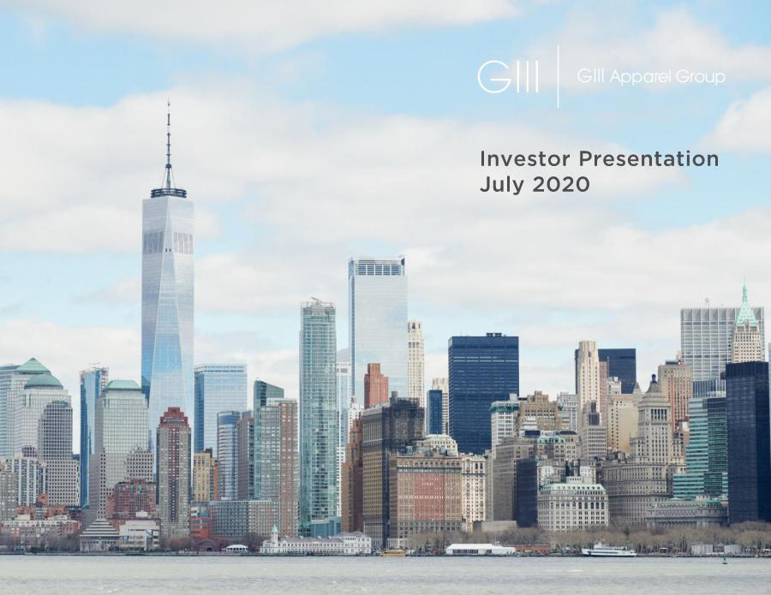

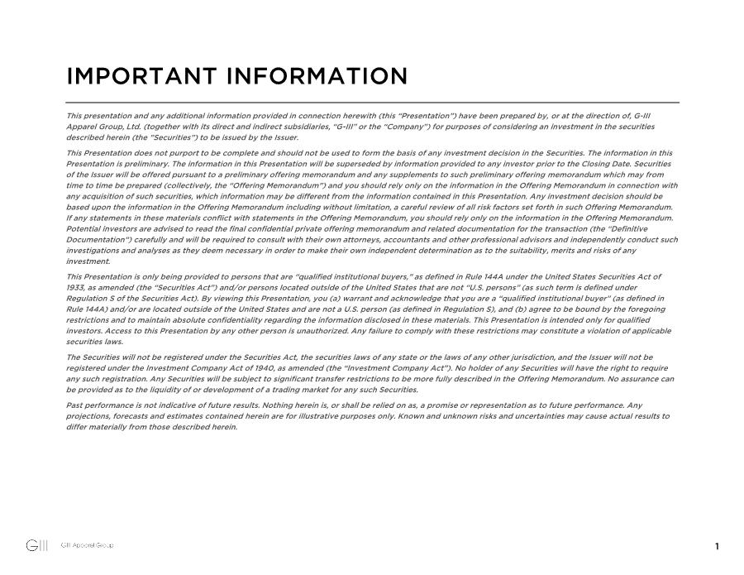

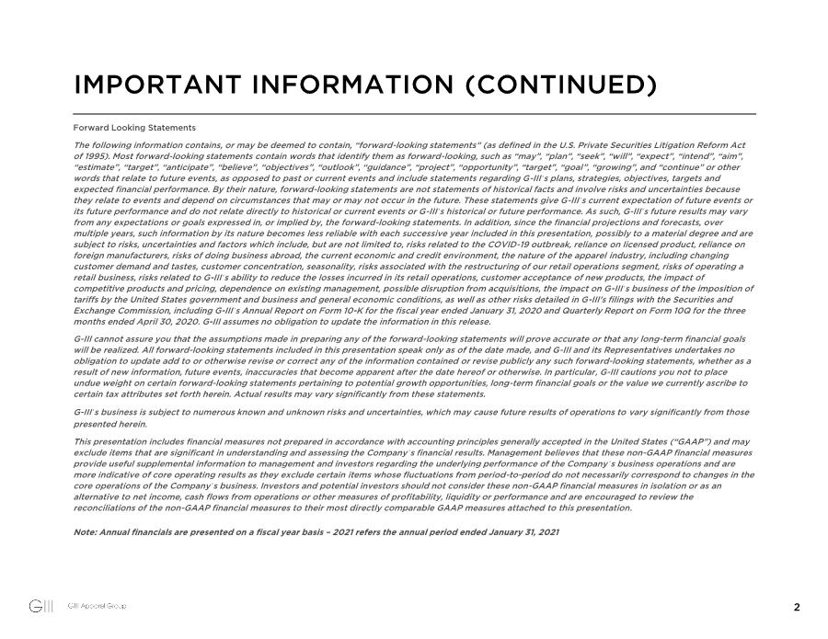

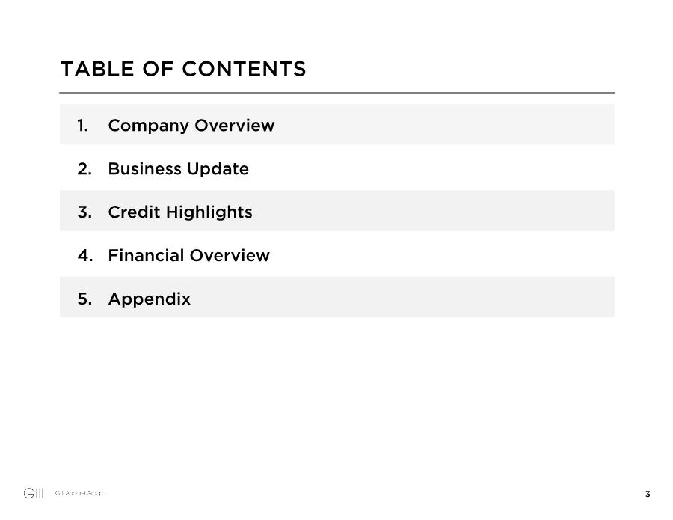



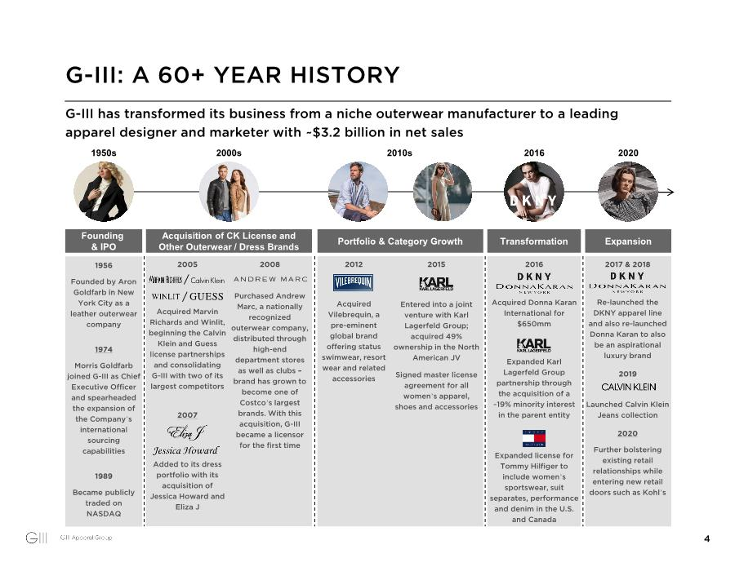

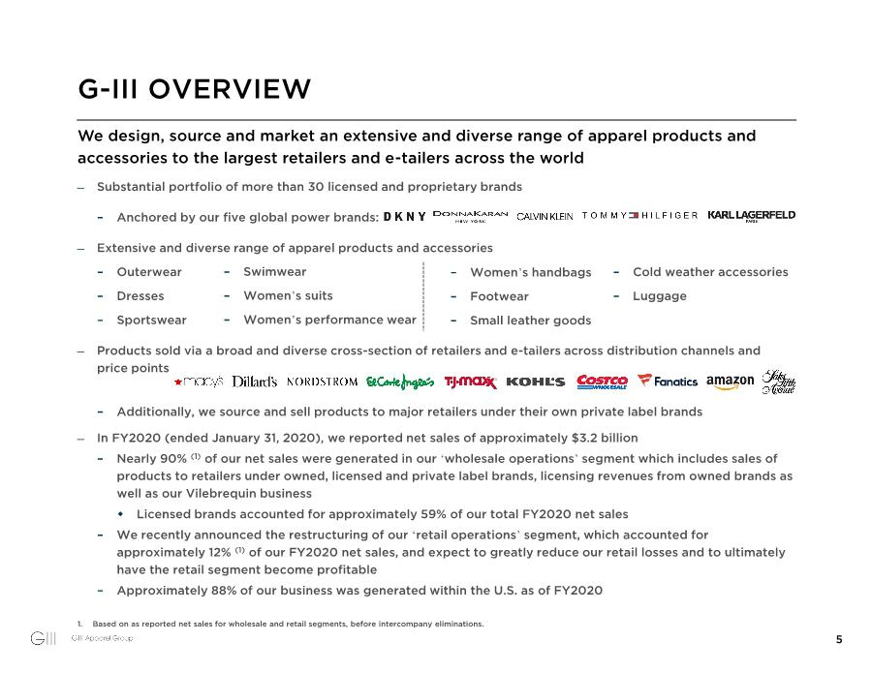

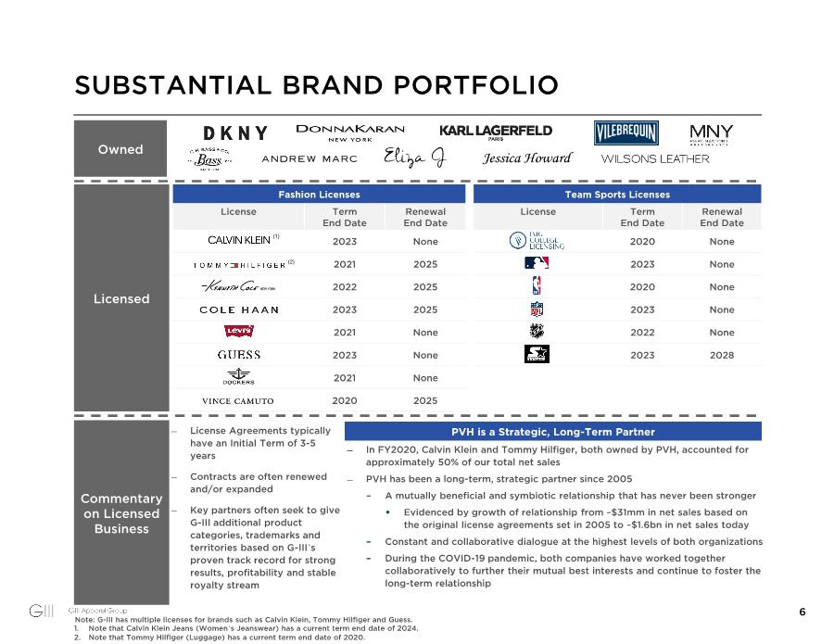

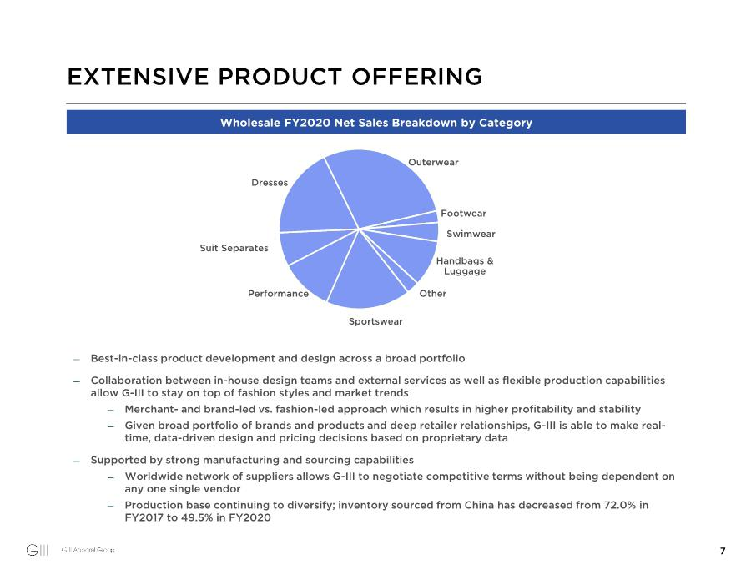

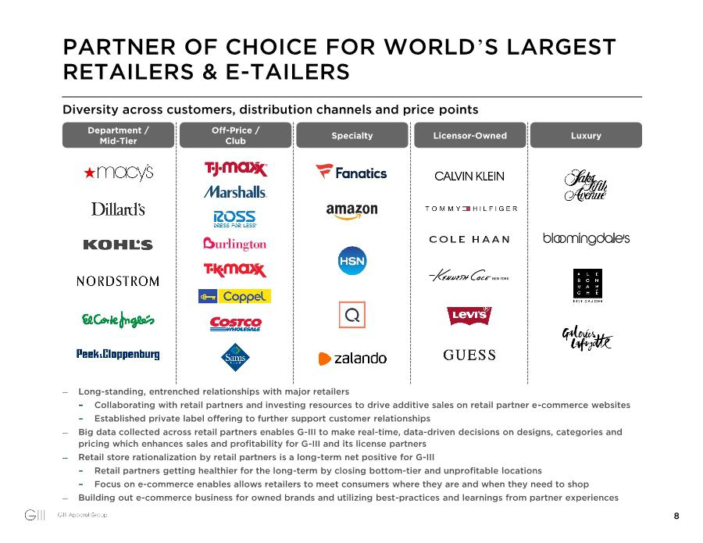



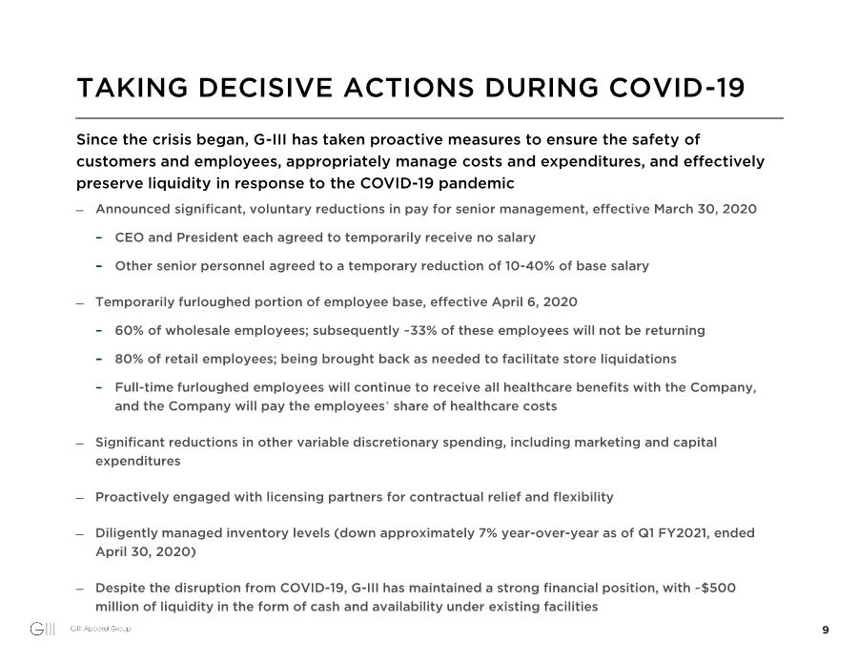

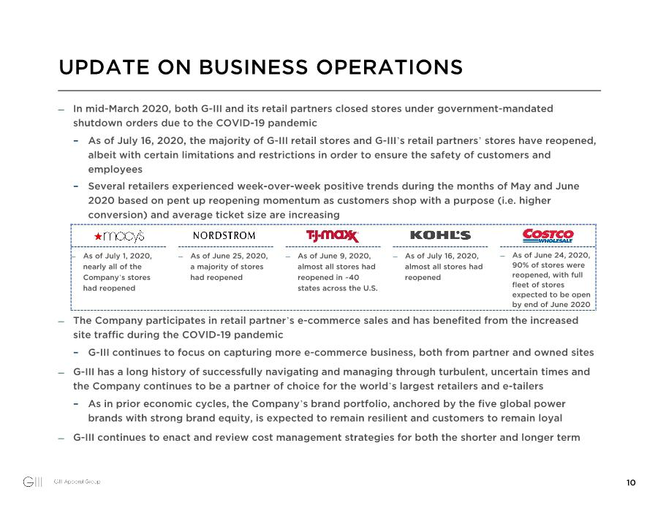

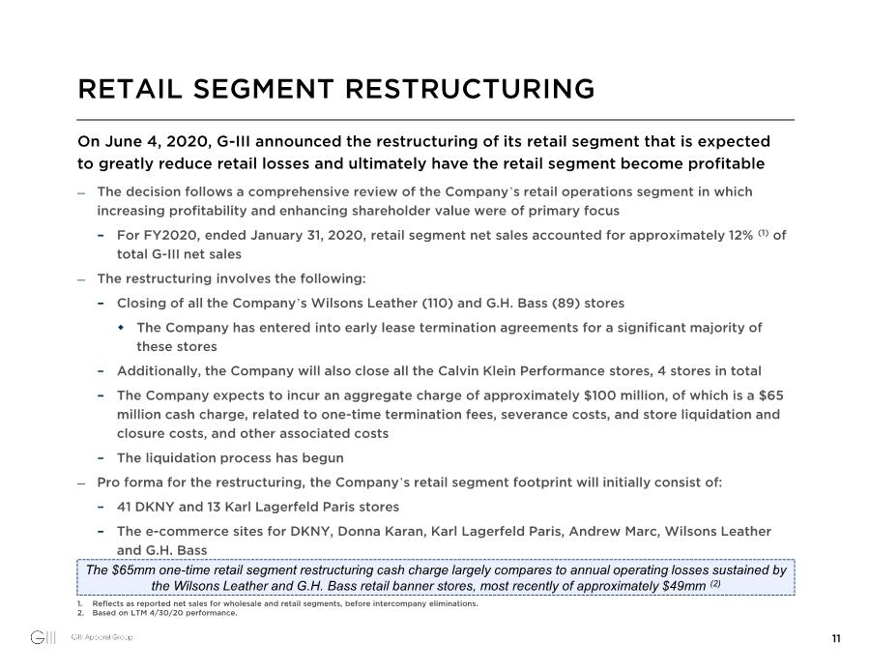

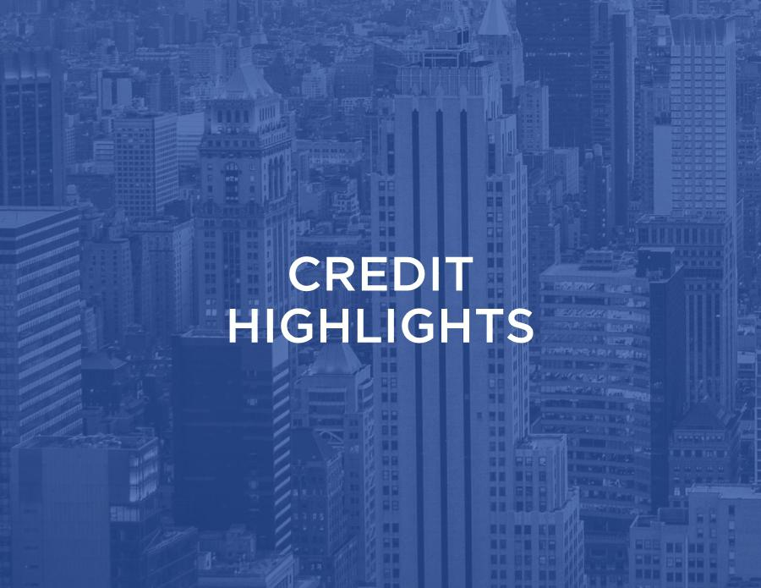

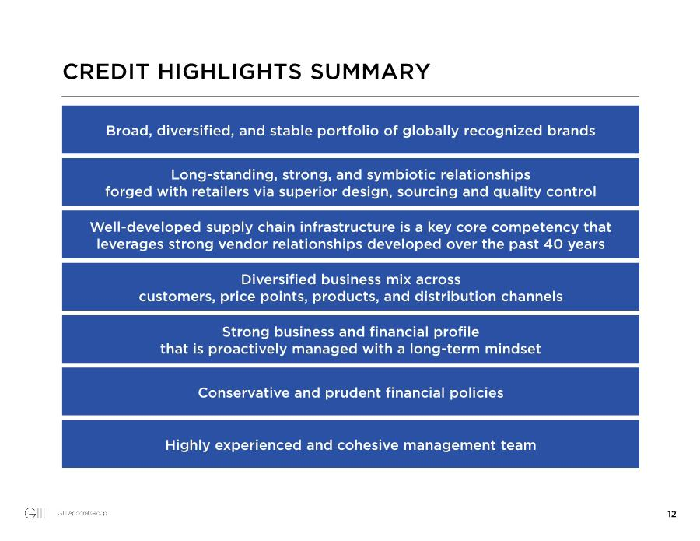

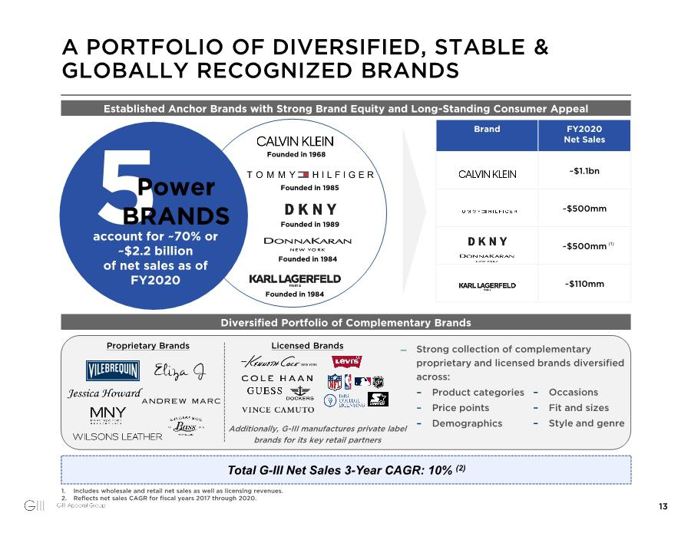

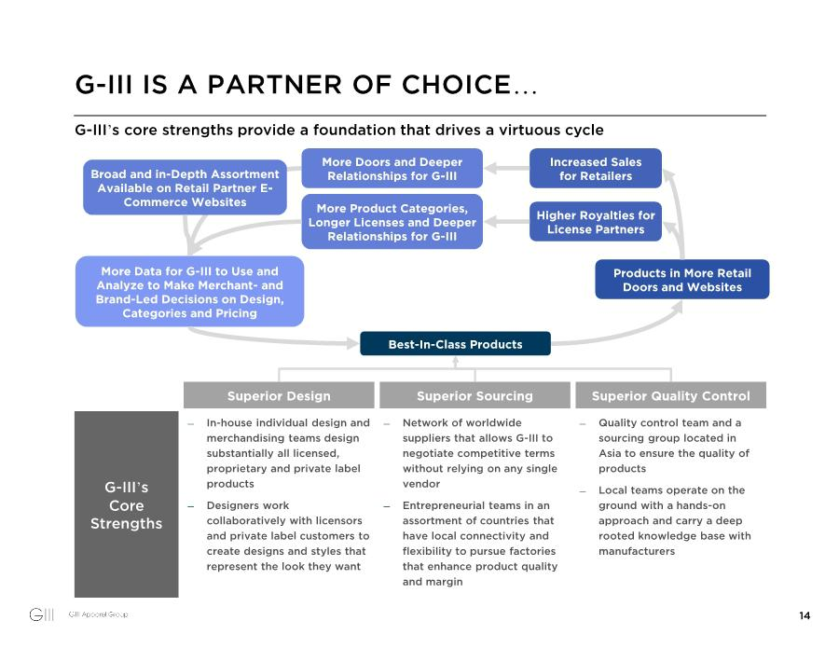

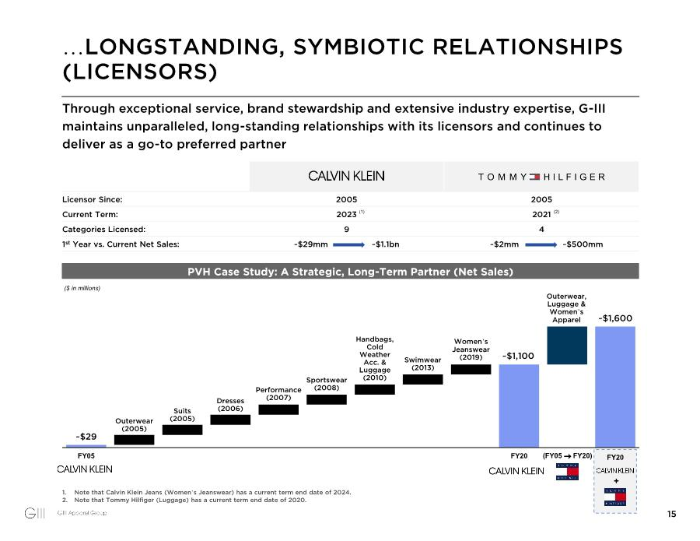

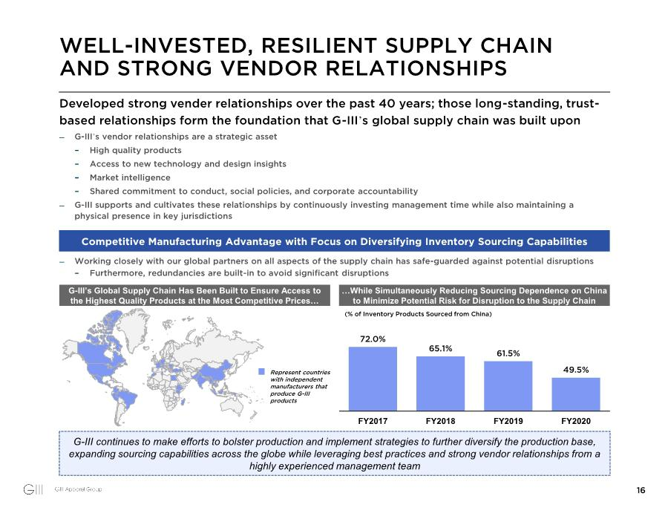

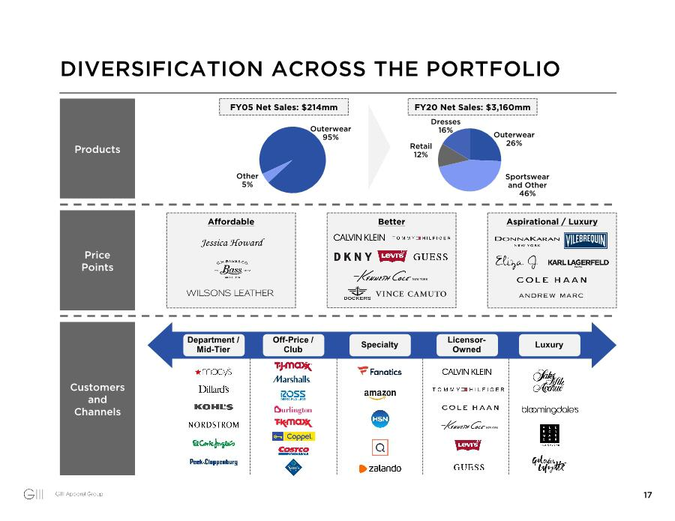

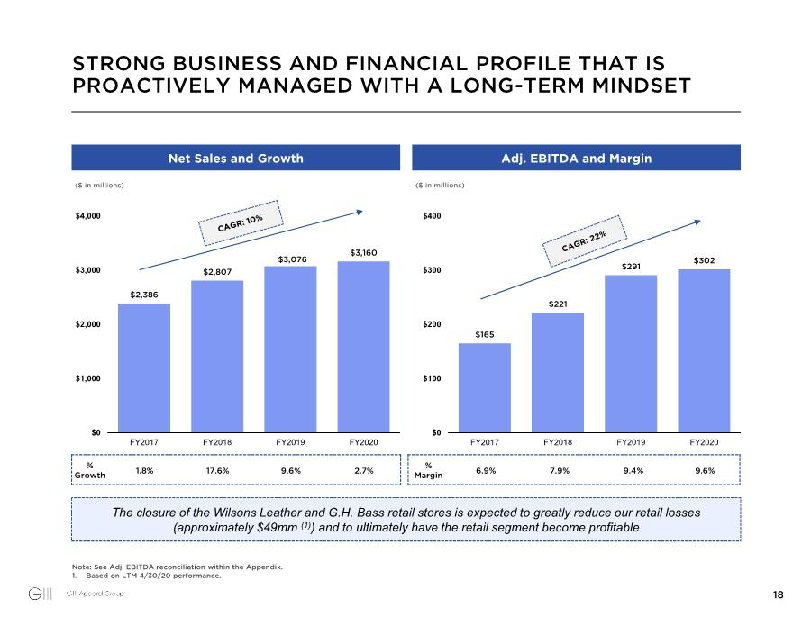

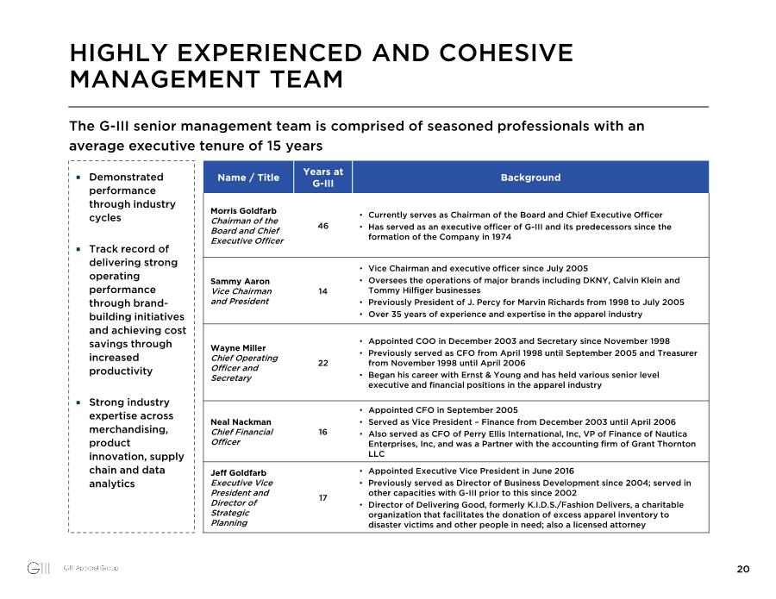



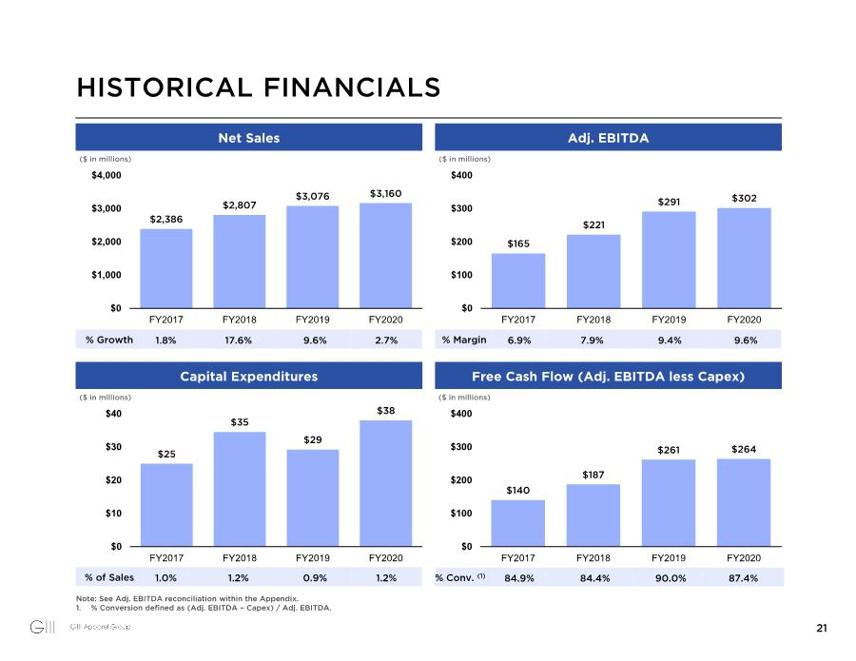

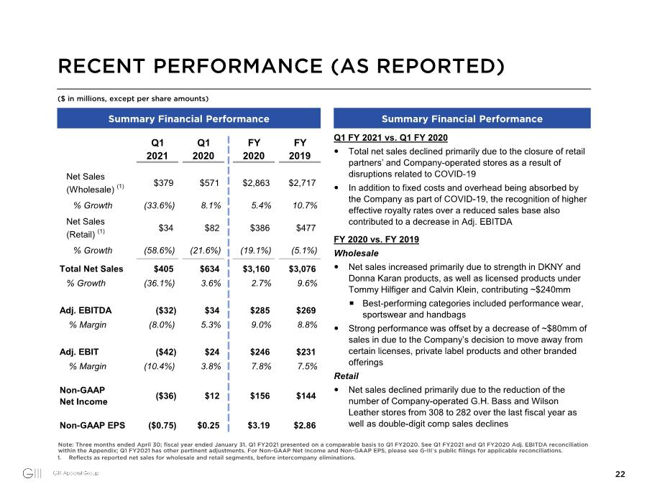

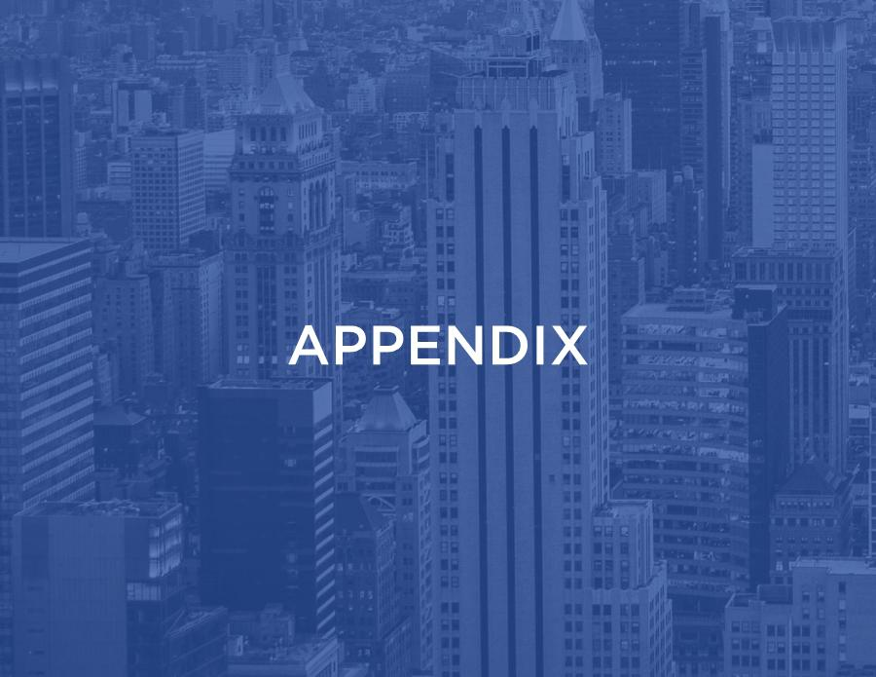

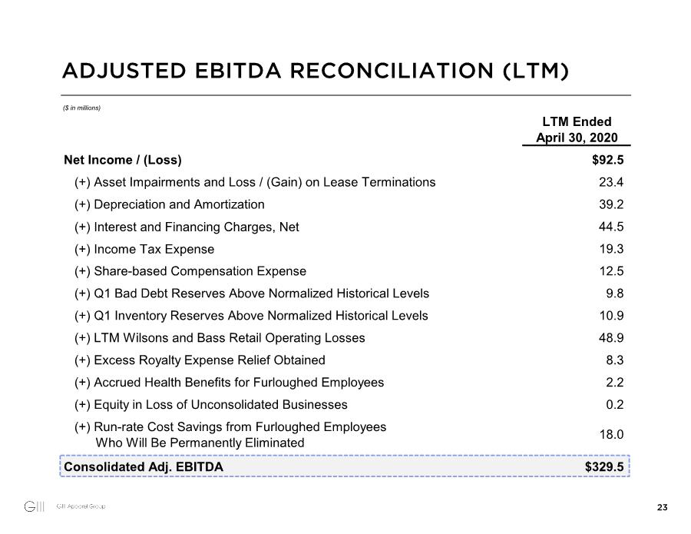

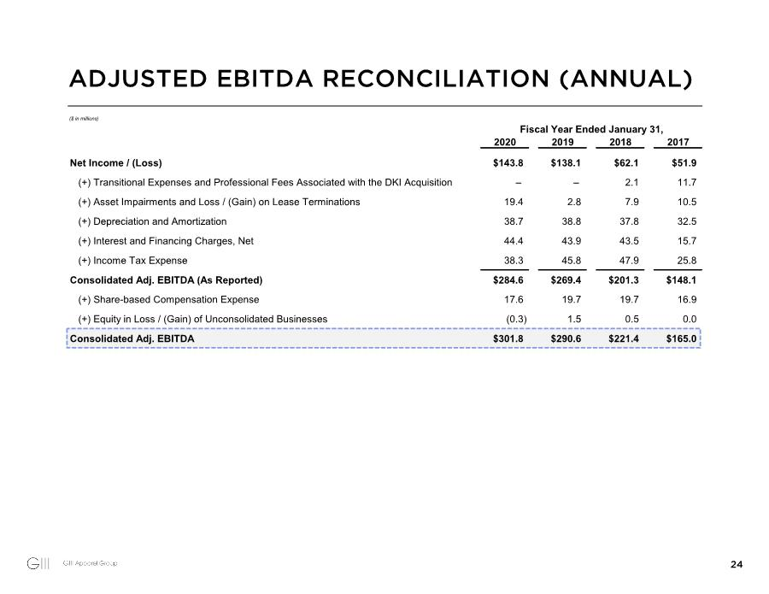

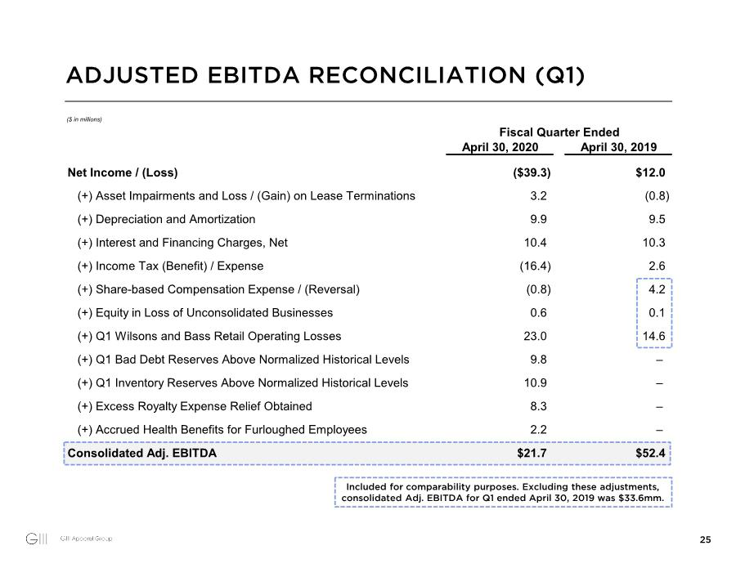

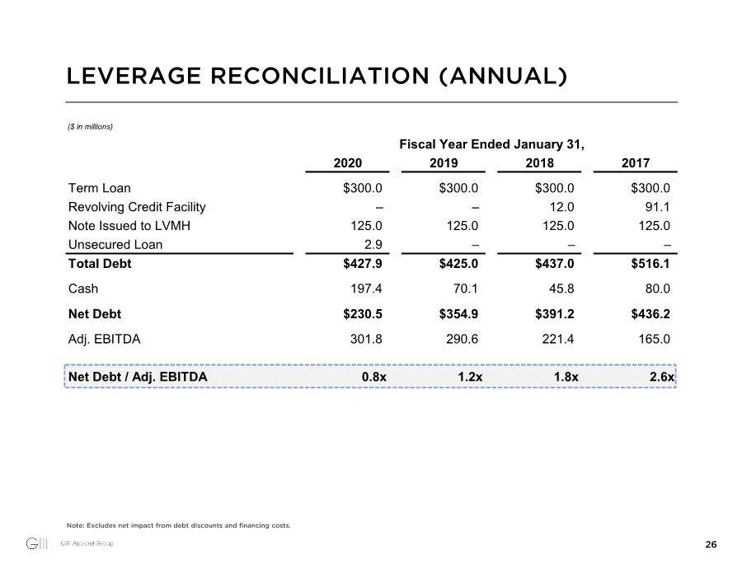

Exhibit 99.3

G-III APPAREL GROUP, LTD.

ANNOUNCES OFFERING OF $350 MILLION OF SENIOR SECURED NOTES DUE 2025

NEW YORK -- July 28, 2020 -- G-III Apparel Group, Ltd. (the “Company”) (Nasdaq GS: GIII) today announced that it intends to offer $350 million aggregate principal amount of Senior Secured Notes Due 2025 (the “Notes”), subject to market and other conditions (the “Offering”).

The Company intends to use the net proceeds of the Offering (i) to repay its existing term loan facility due 2022, (ii) for general corporate purposes and (iii) to pay related fees and expenses.

The Notes will be offered in the United States to persons reasonably believed to be qualified institutional buyers pursuant to Rule 144A under the Securities Act of 1933, as amended (the “Securities Act”), and outside the United States pursuant to Regulation S under the Securities Act. The Notes have not been registered under the Securities Act and may not be offered or sold in the United States absent registration or an applicable exemption from the registration requirements.

This press release is neither an offer to sell nor a solicitation of an offer to buy any securities, nor shall there be any offer, solicitation or sale in any jurisdiction in which such offer, solicitation or sale would be unlawful. Any offers of the Notes will be made only by means of a private offering memorandum. This notice is being issued pursuant to and in accordance with Rule 135(c) under the Securities Act.

About G-III Apparel Group, Ltd.

G-III designs, sources and markets apparel and accessories under owned, licensed and private label brands. G-III’s owned brands include DKNY, Donna Karan, Vilebrequin, G. H. Bass, Eliza J, Jessica Howard, Andrew Marc and Marc New York. G-III has fashion licenses under the Calvin Klein, Tommy Hilfiger, Karl Lagerfeld Paris, Kenneth Cole, Cole Haan, Guess?, Vince Camuto, Levi's and Dockers brands. Through its team sports business, G-III has licenses with the National Football League, National Basketball Association, Major League Baseball, National Hockey League and over 150 U.S. colleges and universities. Through its retail subsidiaries, G-III also operates retail stores under the DKNY, Wilsons Leather, G. H. Bass, Vilebrequin, Karl Lagerfeld Paris and Calvin Klein Performance names. Subsequent to completion of the restructuring of its retail operations segment, G-III will, through two of its wholly-owned subsidiaries, continue to operate stores under the DKNY and Karl Lagerfeld Paris names. G-III, through wholly-owned foreign subsidiaries, will also continue to operate stores under the Vilebrequin name.

Statements concerning G-III's business outlook or future economic performance, anticipated revenues, expenses or other financial items; restructuring plans; product introductions and plans and objectives related thereto; and statements concerning assumptions made or expectations as to any future events, conditions, performance or other matters are "forward-looking statements" as that term is defined under the Federal Securities laws. Forward-looking statements are subject to risks, uncertainties and factors which include, but are not limited to, risks related to the COVID-19 outbreak, reliance on licensed product, reliance on foreign manufacturers, risks of doing business abroad, the current economic and credit environment, the nature of the apparel industry, including changing customer demand and tastes, customer concentration, seasonality, risks associated with the restructuring of our retail operations segment, risks of operating a retail business, risks related to G-III’s ability to reduce the losses incurred in its retail operations, customer acceptance of new products, the impact of competitive products and pricing, dependence on existing management, possible disruption from acquisitions, the impact on G-III’s business of the imposition of tariffs by the United States government and business and general economic conditions, as well as other risks detailed in G-III's filings with the Securities and Exchange Commission. G-III assumes no obligation to update the information in this release.

Contacts:

Company Contact:

Priya Trivedi
VP of Investor Relations and Treasurer

(646) 473-5157

Investor Relations Contact:

Tom Filandro
ICR, Inc.

(646) 277-1235

